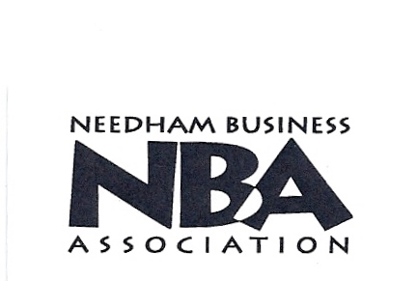 | 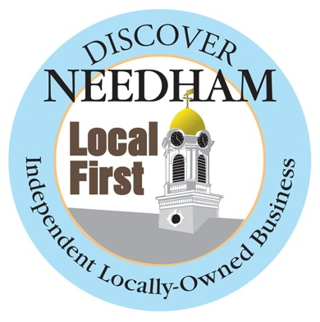
Street Fair Silent Auction Donor Form

The Needham Business Association’s Annual Street Fair is June 1, 2013. The NBA is committed to supporting local businesses by providing a venue for merchants to showcase their products and services at one of Needham’s largest community events.

Sponsors and the silent auction help to fund the Street Fair and Harvest Fair’s entertainment and other NBA sponsored town events. We need your help to make the Silent Auction a success! If you would like to donate an item please submit this form and your donated item by May 24, 2013

Item Description___________________________________________________

_________________________________________________________________

Value of Item__________________________________

Company or Name of Person making donation__________________________
__________________________________________________________________

Address___________________________________________________________

Telephone NO.______________________________________________

Contact Person________________________________________________

Items can be Dropped off at:

Louise Condon Realty
Lois Marks
399 Chestnut Street
781-449-6292

If you are unable to drop off the item, arrangements can be made for the item to be picked up. Call Lois Marks at 781-449-6292

Thank you and we look forward to seeing you on June 1

Grand Sponsors


AND

THE HERON GROUP

